FAST - NUCES

Course taught by Sir Muhammad Toqeer

GROUP MEMBERS:

Minhaaj Saqib (21I-0719)

Hassan Nawaz (21I-2993)

IICT FINAL PROJECT

WEBSITE REPORT

Table of Contents

* Purpose of the Website Pg.2
* First Page (Login/Sign-in) Pg.3
* Second Page (Home) Pg.4
* Third Page (Menu) Pg.5
* Fourth Page(Deals) Pg.6
* Fifth Page (Cart) Pg.7
* Sixth Page (Checkout) Pg.8

Purpose of Website

The website was designed to provide a suitable and user friendly interface to make placing orders from our client fast food restaurant an easy experience.

The website was carefully tailored to meet the requirements detailed in the assignment request file and each instruction was followed carefully to ensure the final product was that which was required.

Each page has the ability to traverse the other available pages through the top header navigation options.

First Page

The first page is the Login/Sign up page. It has both options for new users and returning customers.

The Login side has the option for ‘remember me’ as well for the ease of the customer.

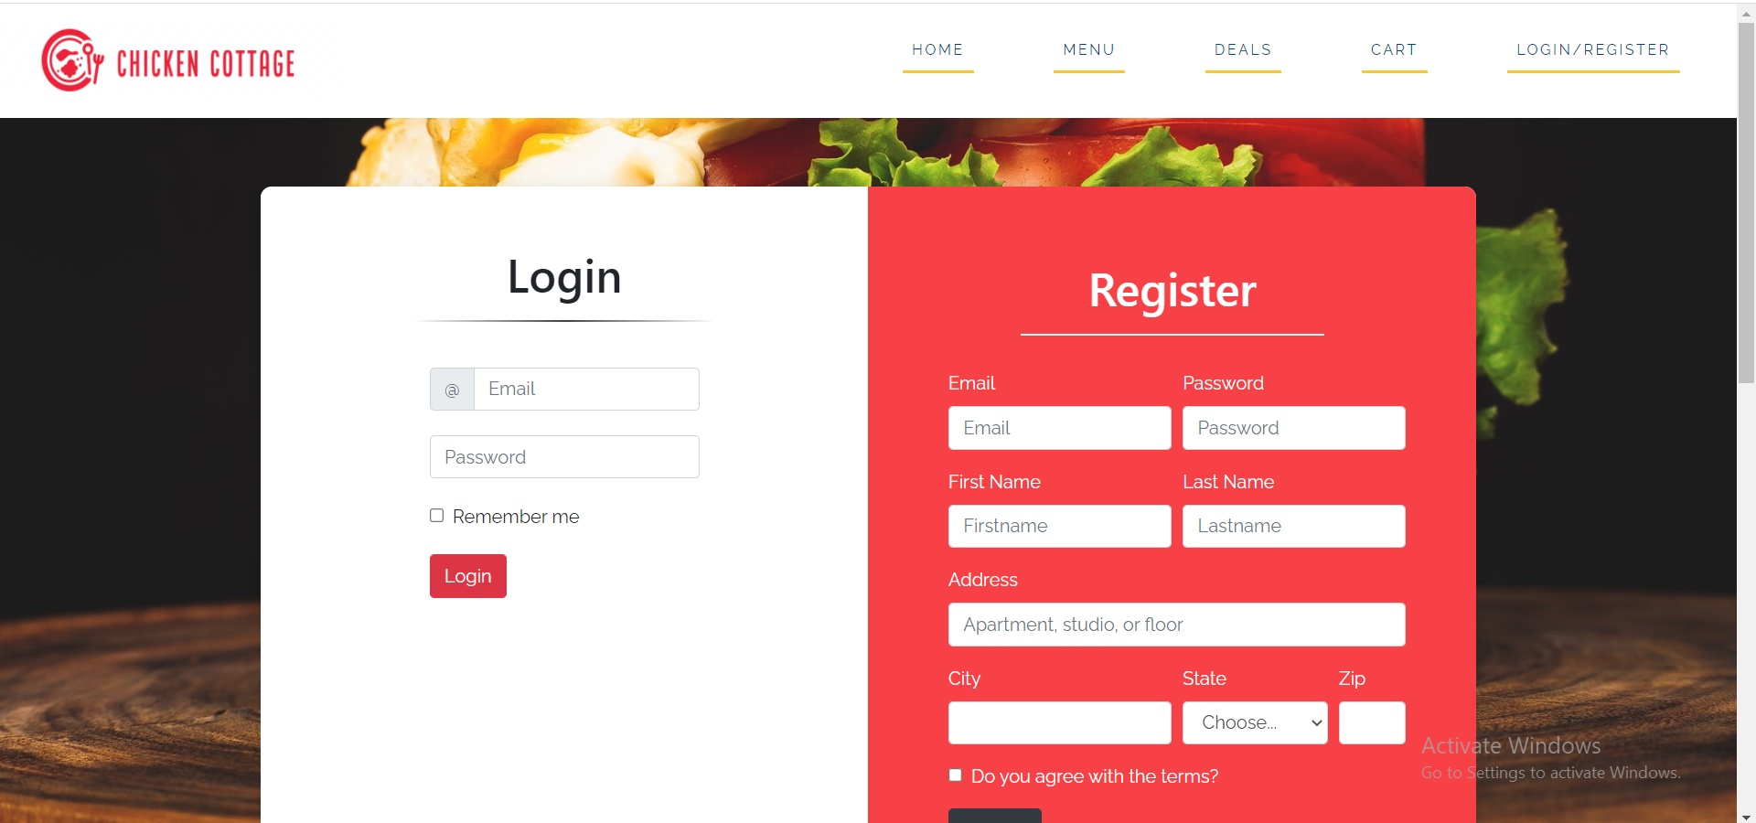

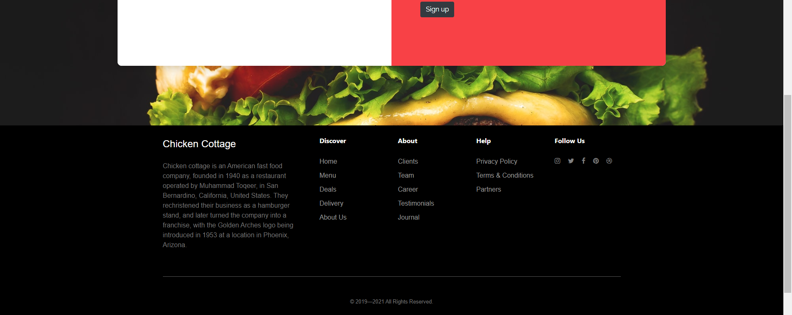

Second Page

The second page is the Home page which introduces the user with which kinds of food the restaurant offers.

The page implements a carousel feature to showcase all the kinds of food offered by the restaurant.

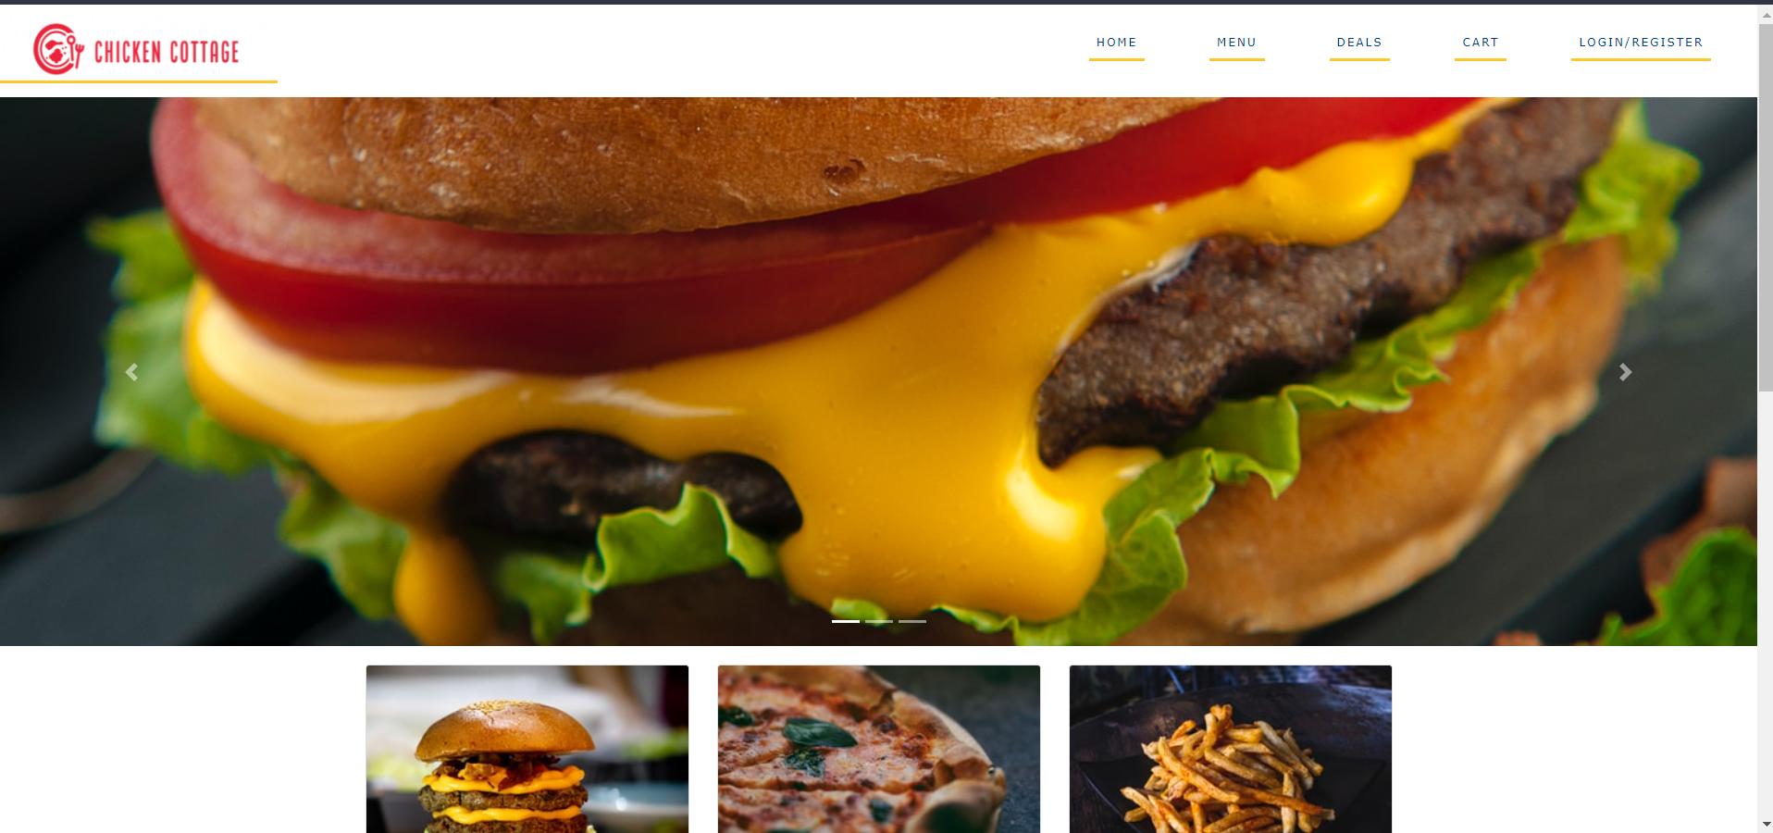

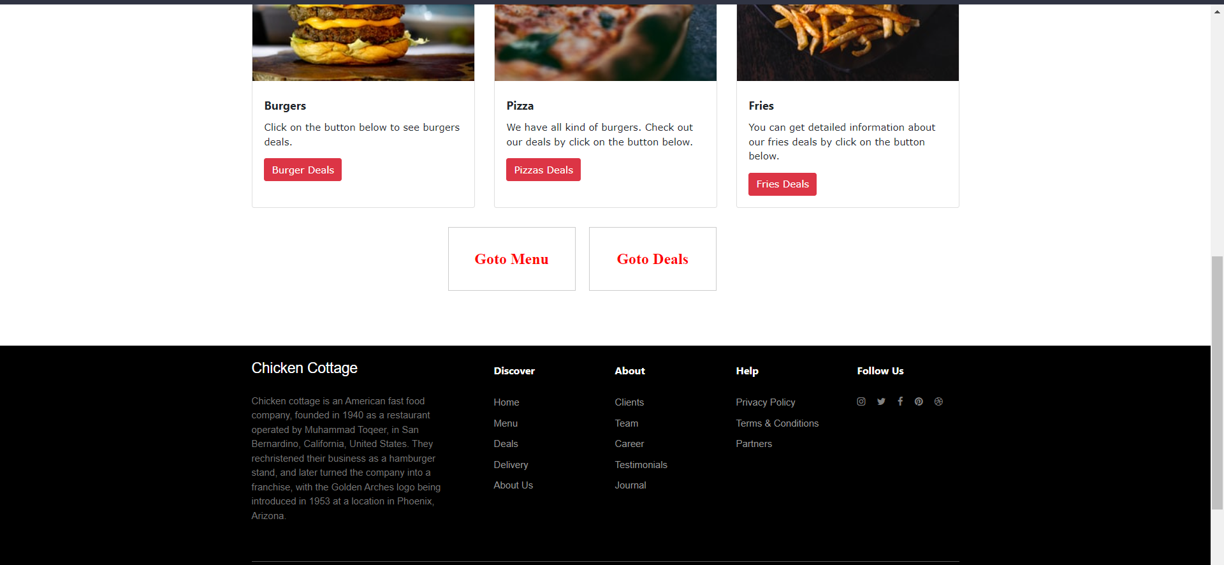

Third Page

The Menu page offers all the items available in an organized manner.

Different sections can be fast traveled by clicking their respective headings.

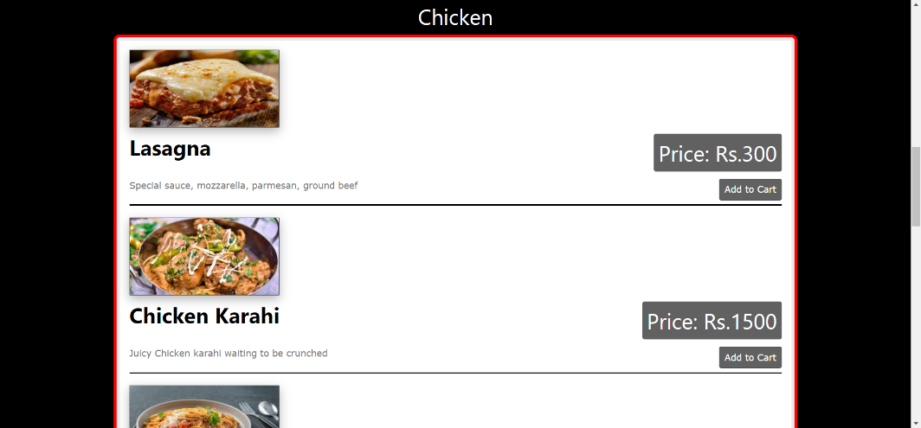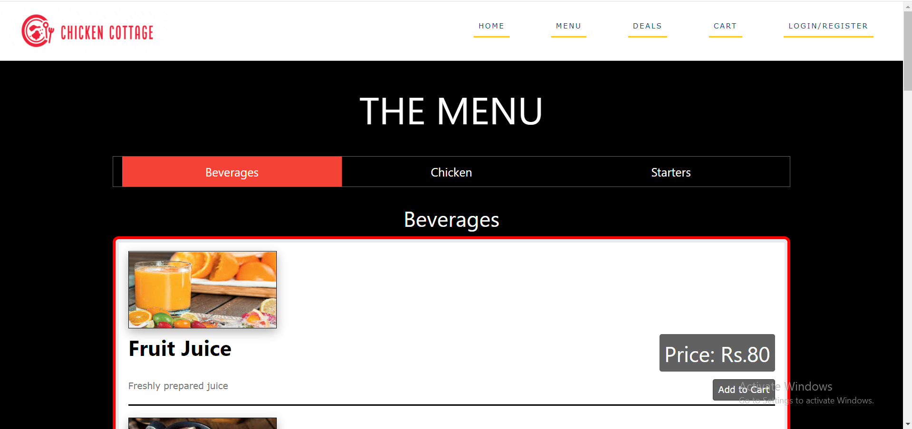  
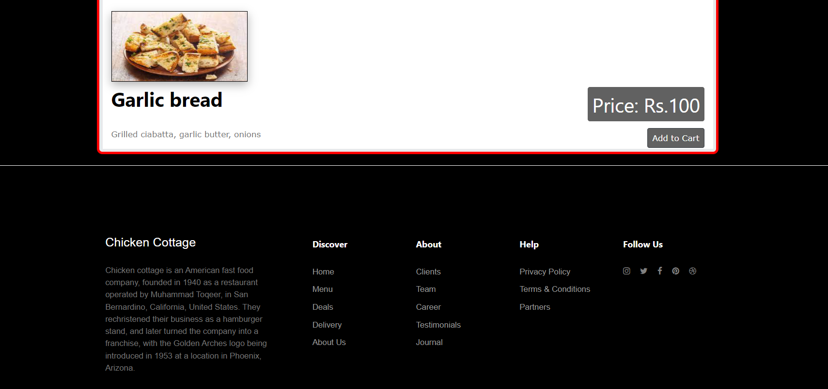

Fourth Page

The Deals page shows all available deals offered by the restaurant.

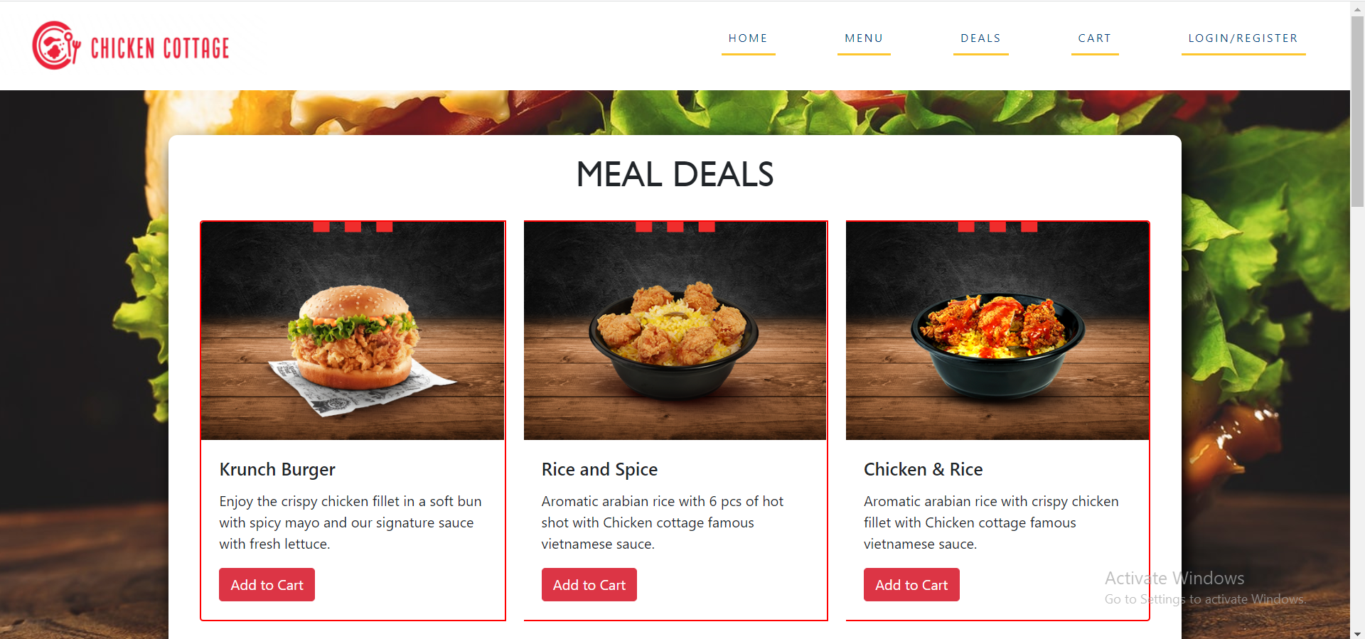

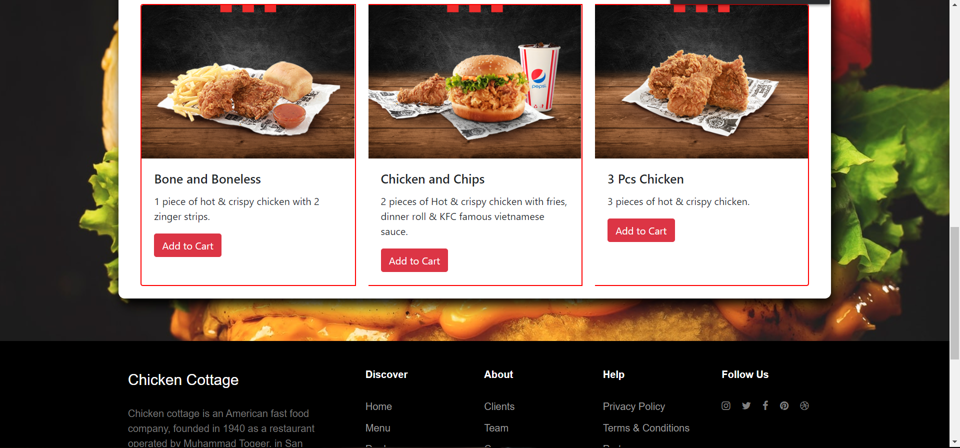

Fifth Page

The Cart page has the chosen items in the list of selected products. Their quantity can be increased with the number bar. Mode of payment can also be selected.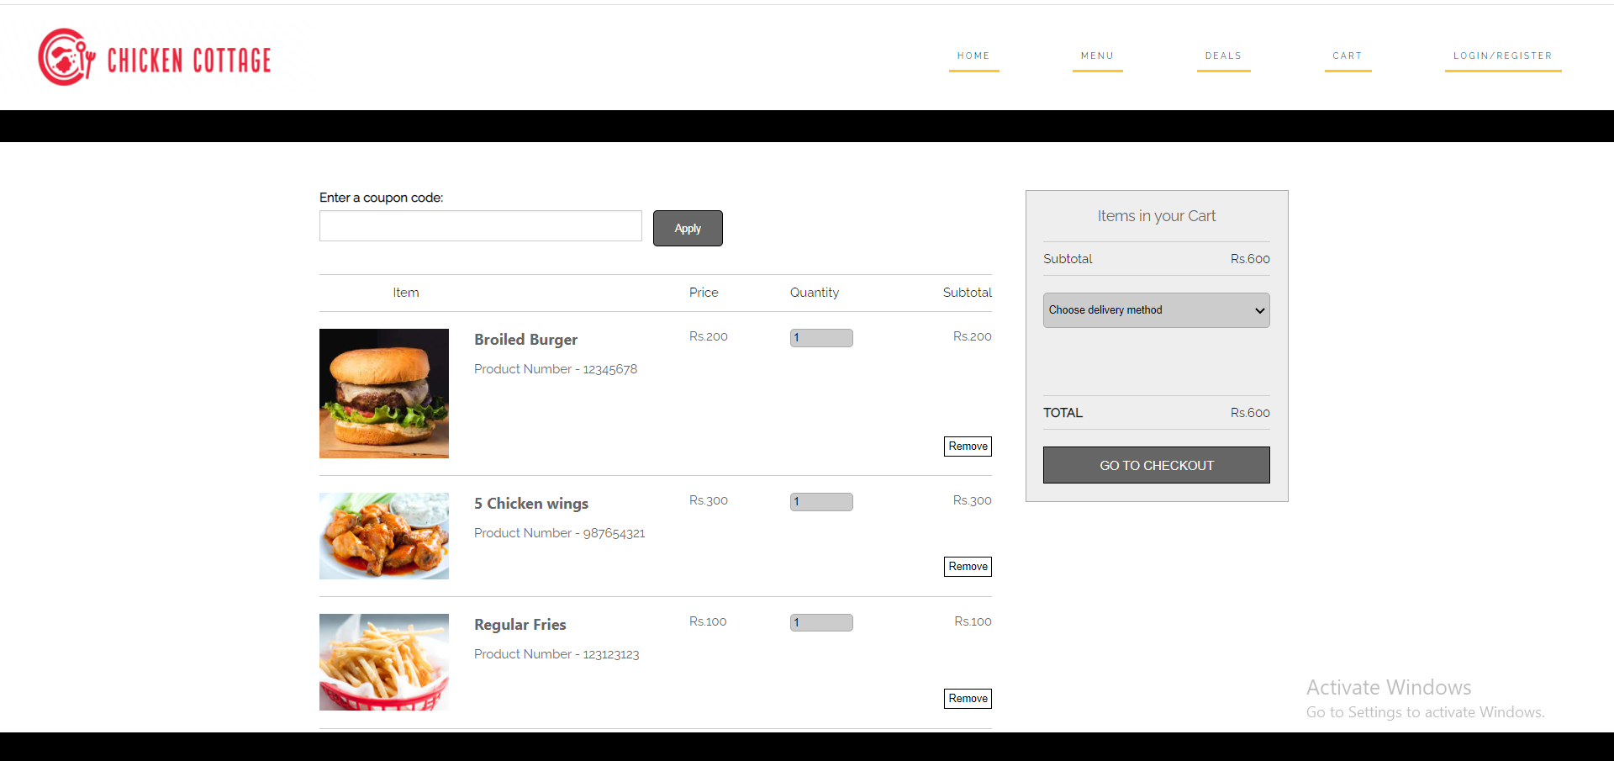

Sixth Page

The Payment page contains all the details required from the user to complete the order.

All fields required are in suitable format as to what is being asked for.

